Sales

# ERD for UX process

ERD diagram

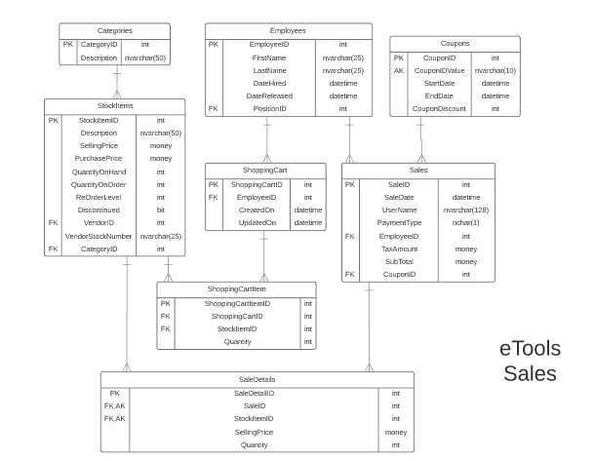

# Possible UX Interface

screen design

Screen 1 : product selection

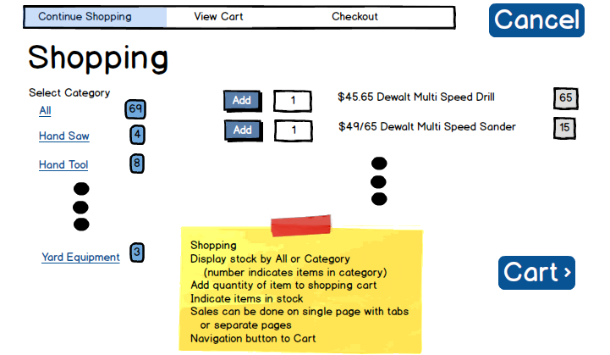

Screen 2:- shopping cart

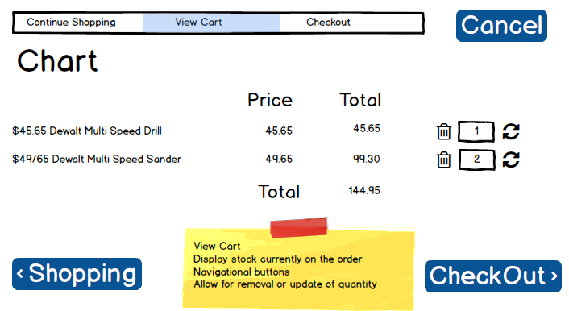

Screen 3:- Checkout

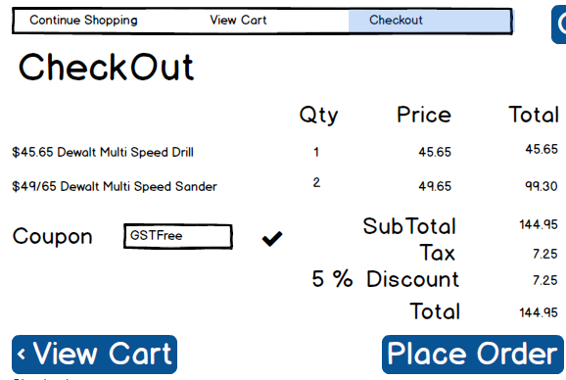

Processing Plan

|  |  |  |
| --- | --- | --- |
| **Controls** | | **Events** |
| categoryDDl | | Wired via object data source |
| **BBL Class(es) and Method (s)** | | |
| category controller | List<SelectionList>List_category()  Retrieve a list of categories | |
| **SQL Table(s): (C,R,U,D)** | | **Entities/DTOs/POCOs** |
| categories | | SelectionList(P) |

|  |  |  |
| --- | --- | --- |
| **Controls** | | **Events** |
| select | | On Click   * Collect Product list * Send to BLL for adding product to cart * Refresh cart |
| **BBL Class(es) and Method (s)** | | |
| productcontroller | List<productlist>List_products()  Retrieve a list of products | |
| **SQL Table(s): (C,R,U,D)** | | **Entities/DTOs/POCOs** |
| stockitems | |  |

|  |  |  |
| --- | --- | --- |
| **Controls** | | **Events** |
| Product Add | | On Click   * Collect Product Information * Send to BLL for adding product to cart * Refresh cart |
| **BBL Class(es) and Method (s)** | | |
| CartConroller | Add_ProductsForCart (int shoppingcartitemid, int shoppingcartid, int stockitemid, int quantity) | |
| **SQL Table(s): (C,R,U,D)** | | **Entities/DTOs/POCOs** |
| Shopping cart(R), Shoppingcartitem(U/D) | |  |

|  |  |  |
| --- | --- | --- |
| **Controls** | | **Events** |
| Delete | | On Click   * Collect Product Information * Send to BLL for adding product to cart * Refresh cart |
| **BBL Class(es) and Method (s)** | | |
| CartConroller | Delete_ProductsForCart (int shoppingcartitemid, int shoppingcartid, int stockitemid, int quantity) | |
| **SQL Table(s): (C,R,U,D)** | | **Entities/DTOs/POCOs** |
| Shopping cart(R), Shoppingcartitem(U/D) | |  |

|  |  |  |
| --- | --- | --- |
| **Controls** | | **Events** |
| Refresh | | On Click   * Collect Product Information * Send to BLL for adding product to cart * Refresh cart |
| **BBL Class(es) and Method (s)** | | |
| CartConroller | Update_ProductsForCart (int shoppingcartitemid, int shoppingcartid, int stockitemid, int quantity) | |
| **SQL Table(s): (C,R,U,D)** | | **Entities/DTOs/POCOs** |
| Shopping cart(R), Shoppingcartitem(U/D) | |  |

|  |  |  |
| --- | --- | --- |
| **Controls** | | **Events** |
| oncheckbox | | On Click   * Verify coupon status |
| **BBL Class(es) and Method (s)** | | |
| couponcontroller | Verify coupon | |
| **SQL Table(s): (C,R,U,D)** | | **Entities/DTOs/POCOs** |
| coupons | |  |

|  |  |
| --- | --- |
| **Controls** | **Events** |
| Shopping Button | * Takes to the shopping form |

|  |  |
| --- | --- |
| **Controls** | **Events** |
| View cart | * Takes to shopping cart web form |

|  |  |
| --- | --- |
| **Controls** | **Events** |
| Checkout | * Takes to checkout web form |

|  |  |  |
| --- | --- | --- |
| **Controls** | | **Events** |
| Place Order | | Save On Click   * Collect Product from shopping cart * Send to BLL for saving |
| **BBL Class(es) and Method (s)** | | |
| CartConroller | Update_ProductsForCart (int shoppingcartitemid, int shoppingcartid, int stockitemid, int quantity) | |
| **SQL Table(s): (C,R,U,D)** | | **Entities/DTOs/POCOs** |
| Shopping cart(U) | |  |

Comments

Your work does not demonstrate to me you have any deep understanding of this subsystem. Your planning lacks details. You have a lot of work ahead of yourself and you do not seem to know or convey understanding of the work needed.